display(dbutils.fs.ls("/FileStore/tables"));

output :-

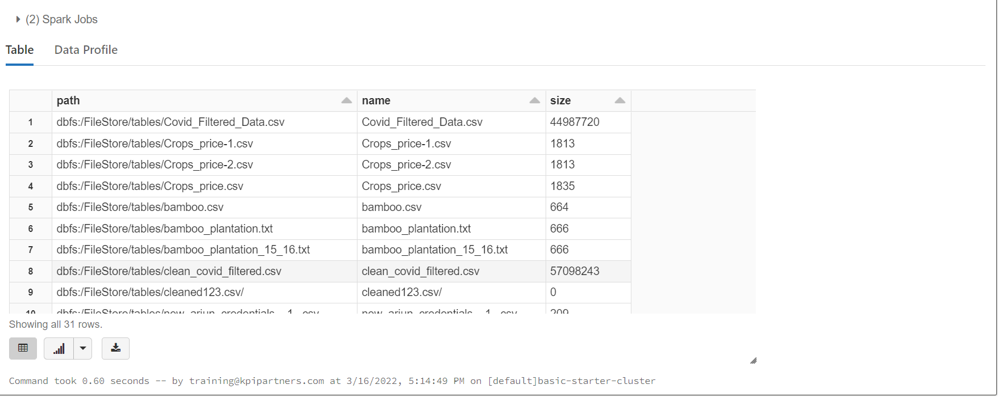

from pyspark import SparkContext

from pyspark import SparkConf

from pyspark.sql import SparkSession

from pyspark.sql.types import StructType, StructField, StringType, IntegerType,FloatType

import re

df= spark.read.csv("dbfs:/FileStore/tables/owid_covid_data.csv")

df.collect()

output :-

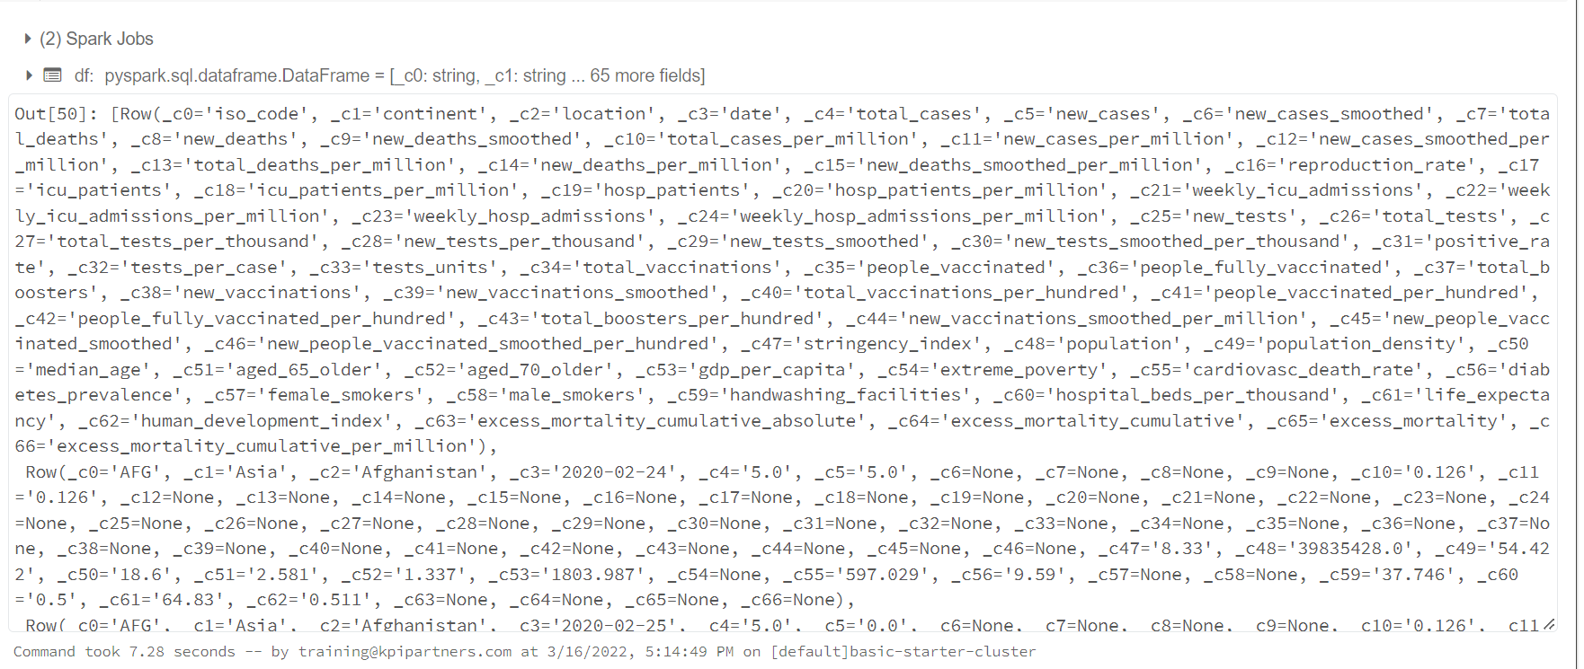

1.Replace all the negative values & null values with zero.

df1=df.fillna(0);

for i in range(len(df)):

if (df.at[i,'new_cases'])<0:

df.at[i,'new_cases']=0

if (df.at[i,'new_cases_smoothed'])<0:

df.at[i,'new_cases_smoothed']=0

if (df.at[i,'new_deaths'])<0:

df.at[i,'new_deaths']=0

if (df.at[i,'new_deaths_smoothed'])<0:

df.at[i,'new_deaths_smoothed']=0

if (df.at[i,'new_cases_per_million'])<0:

df.at[i,'new_cases_per_million']=0

if (df.at[i,'new_cases_smoothed_per_million'])<0:

df.at[i,'new_cases_smoothed_per_million']=0

if (df.at[i,'new_deaths_per_million'])<0:

df.at[i,'new_deaths_per_million']=0

if (df.at[i,'new_deaths_smoothed_per_million'])<0:

df.at[i,'new_deaths_smoothed_per_million']=0

if (df.at[i,'reproduction_rate'])<0:

df.at[i,'reproduction_rate']=0

if (df.at[i,'excess_mortality_cumulative_per_million'])<0:

df.at[i,'excess_mortality_cumulative_per_million']=0

if (df.at[i,'excess_mortality'])<0:

df.at[i,'excess_mortality']=0

if (df.at[i,'excess_mortality_cumulative'])<0:

df.at[i,'excess_mortality_cumulative']=0

if (df.at[i,'excess_mortality_cumulative_absolute'])<0:

df.at[i,'excess_mortality_cumulative_absolute']=0

if (df.at[i,'excess_mortality_cumulative'])<0:

df.at[i,'excess_mortality_cumulative']=0

2.remove the records where the continent column having blanks

for i in range(len(df)):

if (df.at[i,'continent'])==0 : # (pd.isnull(df.at[i,'continent']) or

df.drop([i], axis=0, inplace=True)

df1=spark.read.format("csv").option("header","true").load("dbfs:/FileStore/tables/Covid_Filtered_Data.csv")

df1.show();

df1.createOrReplaceTempView("Covid")

Using SQL :-

%sql

3. display the continent,positivity rate where the strigency index is maximum

select continent,positive_rate, max(stringency_index) as stringency_index from Covid

group by continent,positive_rate

limit 5;

output :-

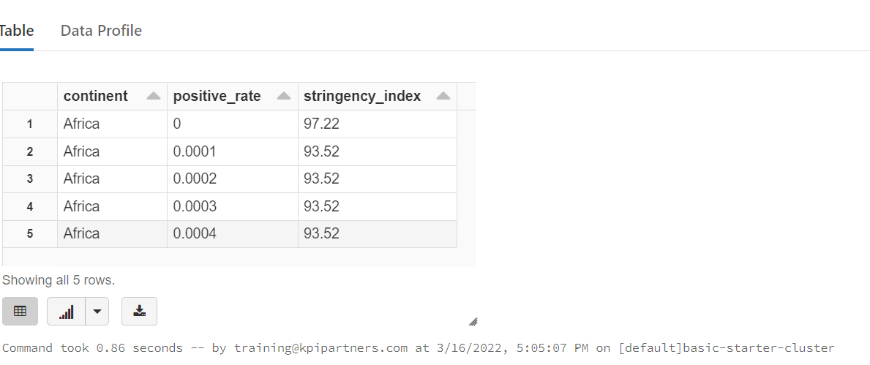

%sql

4. which continent and location having max of deaths and male_smokers

select continent,location,max(total_deaths) as max_deaths ,max(male_smokers)as smokers from Covid

group by continent,location;

output :-

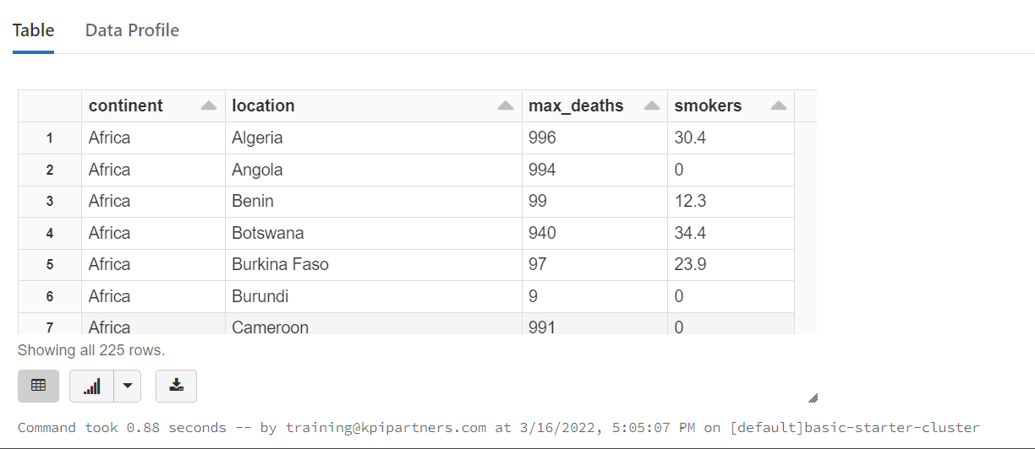

5. which year having the highest number of deaths

%sql

select max(total_deaths),year(date) as year from Covid group by(year)

order by year

limit 10;

output :-

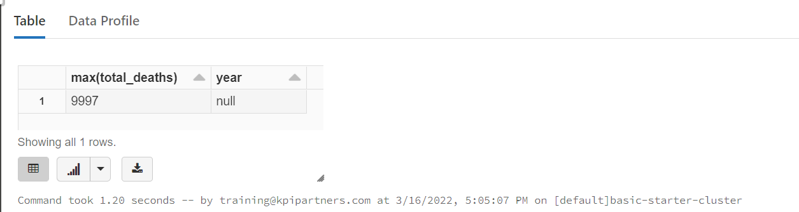

6. which location having lowest recovery rate for each continent

Using python :-

from pyspark import SparkContext

from pyspark import SparkConf

from pyspark.sql import SparkSession

from pyspark.sql.types import StructType, StructField, StringType, IntegerType,FloatType

import re

df1 = spark.read.format("csv").option("header", "true").load("dbfs:/FileStore/tables/Covid_Filtered_Data.csv")

df1.createOrReplaceTempView("Covid")

df1.show()

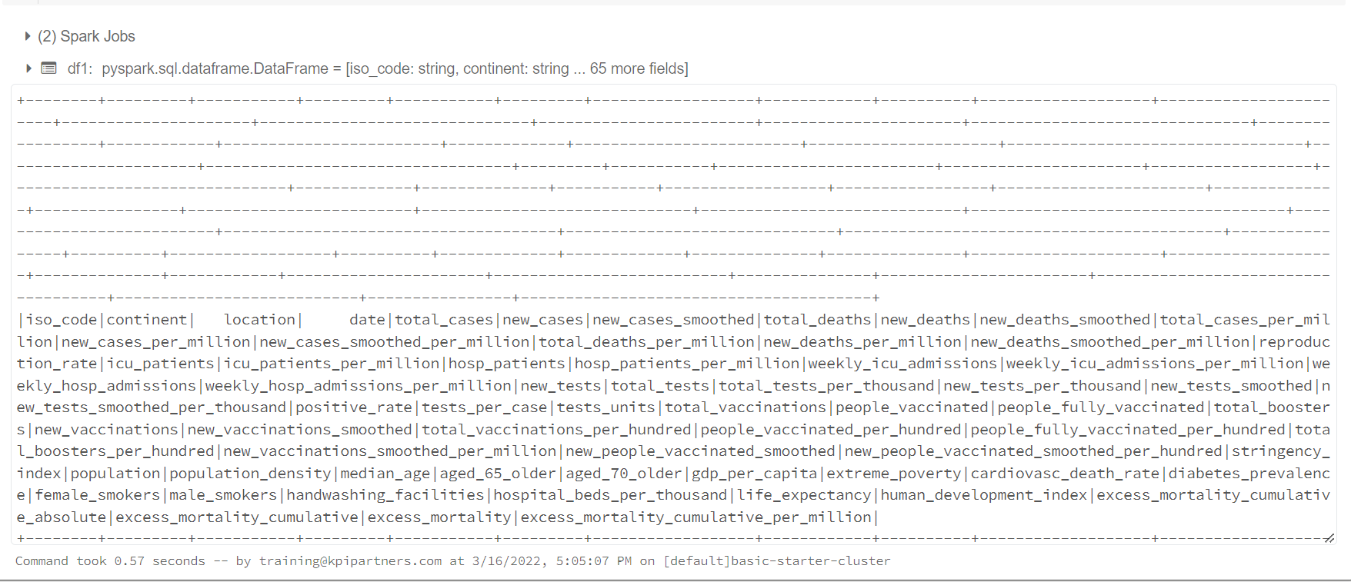

df1=spark.sql("select first(location),first(total_cases - total_deaths) as recovery from Covid group by(continent) ").show()

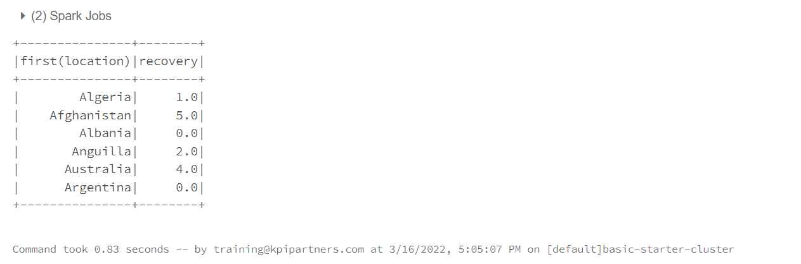

7. Countries with max cardiovasc_death_rate and diabetes_prevalence greater than 10

Using Scala :-

%scala

import org.apache.spark.sql.SparkSession

"""from scalaspark.sql.functions import *"""

val df = spark.read.csv("dbfs:/FileStore/tables/Covid_Filtered_Data.csv")

df.show()



%scala

df.createOrReplaceTempView("covid")

%scala

spark.sql(" select first(_c2) as countrys , max(_c55) as cardiovasc_death_rate from covid where _c56 >10 ;").show()

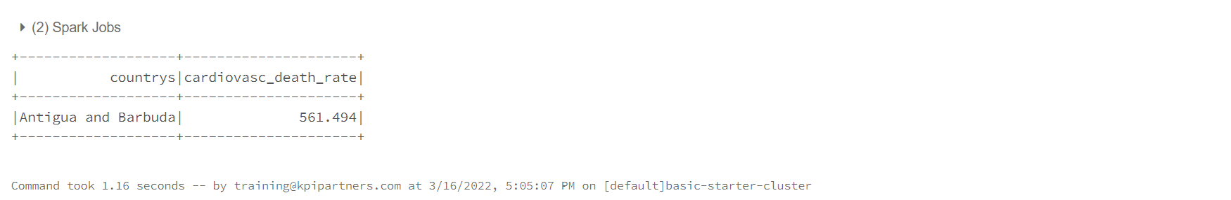

8. which location has highest number of vaccinated people in each continent

%scala

spark.sql("select first(_c2),max(_c35) as Vaccination from Covid group by _c2 order by Vaccination").show();

output :-

